30/11/2019

**Task:**

* Send a package with 500 samples to reduce latency on data transfer
* Send struct of float arrays

**Issue:** Vibration capture is reduced due the latency of the serial communication, affecting ploting.

**Solution:** Created a buffer to hold 500 samples in the microcontroller and write it on the serial using a structc of float arrays.

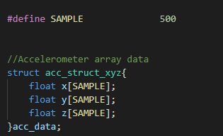

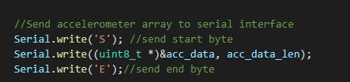

In python add the lib struct and used method unpack that returns a tuple of floats.

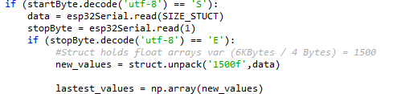

References

https://docs.python.org/3/library/struct.html

https://www.geeksforgeeks.org/struct-module-python/

<https://stackoverflow.com/questions/13401600/unpack-binary-data-with-python>

https://forum.arduino.cc/index.php?topic=416340.0

https://arduino.stackexchange.com/questions/22219/transfer-a-structs-data-to-an-external-struct-via-serial

https://overiq.com/c-programming-101/array-as-member-of-structure-in-c/